激光带打印机电源

www.jensin.cn

JA350OKA
·114.5 W 风扇冷却
·功效达 80%
·AC输出600W峰值
·尺寸: 177.5(L) X150(W) X 60(H)mm
·UL\CSA 安全认证
·5 年保修期
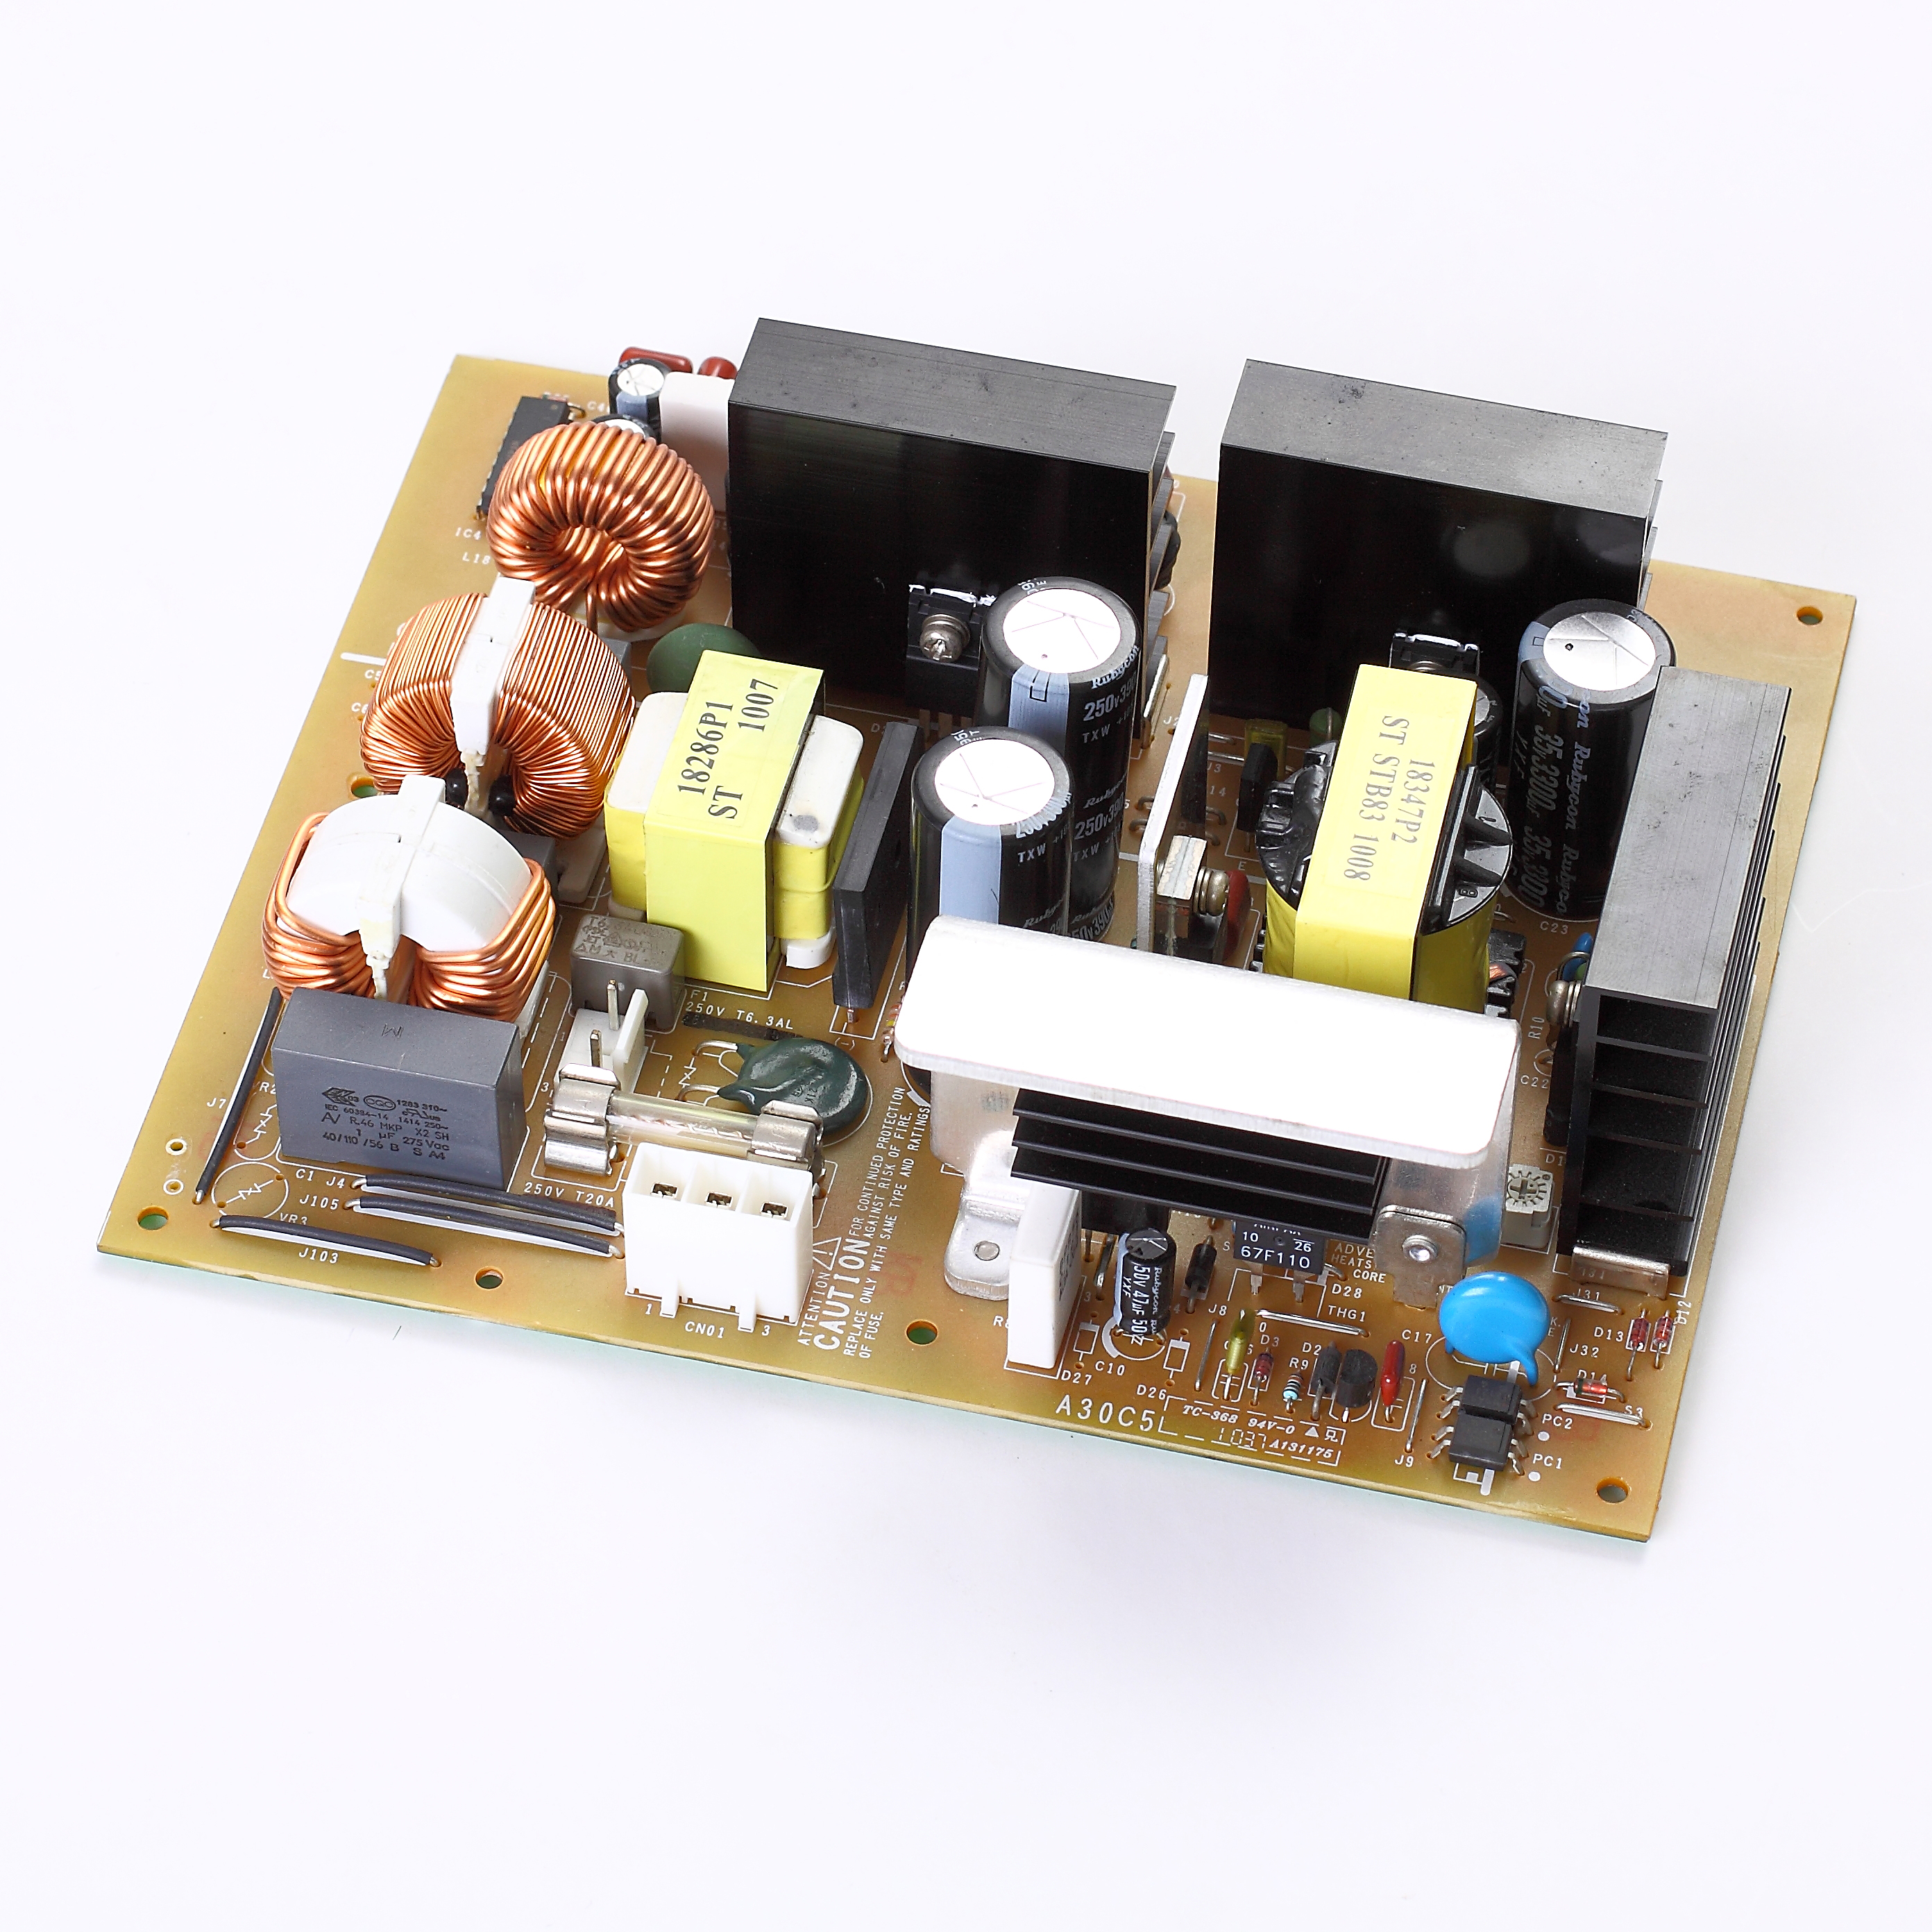

GREEN·POWER
规格

输入
输入电压 | ·85-140 VAC/187-276 VAC
输入频率 | ·47-63 Hz
输入电流 | ·2.5 A max at 100 VAC, full load  ·1.2 A max at 230 VAC, full load
浪涌电流 | ·30 A max at 230 VAC,  ·20 A max at 100 VAC, cold start at 25 °C
输入保护 | ·100VAC：Internal T20A250V and 6.3A250V fuse inLine and neutral  ·230VAC：Internal T10A250V and  3.15A250V fuse inLine and neutral
输出
输出电压 | ·V1:5 VDC,V2:24VDC
输出电流 | ·8.5A V1,3A V2 (Rating)
输出电压修正 | ·+4%,-2% V1,±3%V2
初始设置精度 | ·±0.5% V1
最小负载 | ·0.1A V1; 0.05A V2
最大负载 | ·12A V1; 5A V2
启动延迟 | ·1.6S max
启动上升时间 | ·0.1S max
保持时间 | ·20 ms min at 100 VAC or 220VAC
温度漂移 | ·±0.2% after 20 min warm up
线路调节 | ·±0.5% max
负载调节 | ·±1% V1, ±1% V2
瞬态响应 | ·2% max. deviation, recovery to within  1% in 500 µs for a 50-75-50% load  change
波纹和噪声 | ·200mV pk-pk, bandwidth full
过压保护 | ·7V max V1, 31V max V2  (V1、V2recycle input to reset)
过载保护 | ·15A max V1,8A max V2  (V1、V2recycle input to reset)
短路保护 | ·recycle input to reset（V1、V2）
温度保护 | ·110℃ max  recycle input to reset
AC DC
常规
功效 | ·Up to 80% at rating load
隔离 | ·3300 VAC 2S Input to Output,  3300 VAC 2S Input to Ground,
控制信号 | ·Non
MTBF | ·100000H or more
环境
工作温度 | ·0 °C to +50 °C
冷却 | ·Fan cooled
工作湿度 | ·15-90% RH, non-condensing
储存温度 | ·-10 °C to +65 °C Non binding
工作高度 | ·3000 m max
震动 | ·50mm highly vertical drop 2 times  on the ground or plate
振动 | ·Operating 0.3g, No Operating 1g,  Number of vibration :5-150Hz,1 minutes  Times: 30 minutes/direction,3 direction(1.5H)
EMC和安全
排放 | ·EN55022 Class B、VCC I Class B 、FCC \ Class B
交流线路抗噪声 | ·JEITA IT-3001、EN55024(EN61000-4-4)
辐射噪音 | ·EN55022 Class B、VCC I Class B 、FCC Class B
静电噪音 | ·JEITA IT-3001、EN55024(EN61000-4-2)
浪涌 | ·EN55024（EN61000-4-5）
传导噪音 | ·EN55022 Class B、VCC I Class B 、FCC Class B
安全认证(100-127V) | ·UL60950-1, CSA C22.2 No.60950-1,  IEC60950-1, J60950.
安全认证(220-240V) | ·EN60950-1, IEC60950-1

SHENZHEN CEC PANDA JENSIN TECHNOLOGY CO., LTD

