多功能打印机电源

www.jensin.cn

JA286OKA
·75 W 风扇冷却
·150 W 峰值
·功效达 75%
·AC输出750W峰值
·尺寸: 155(L) X 90(W) X 32(H)mm
·UL\CB\DEMKO 安全认证
·5 年保修期
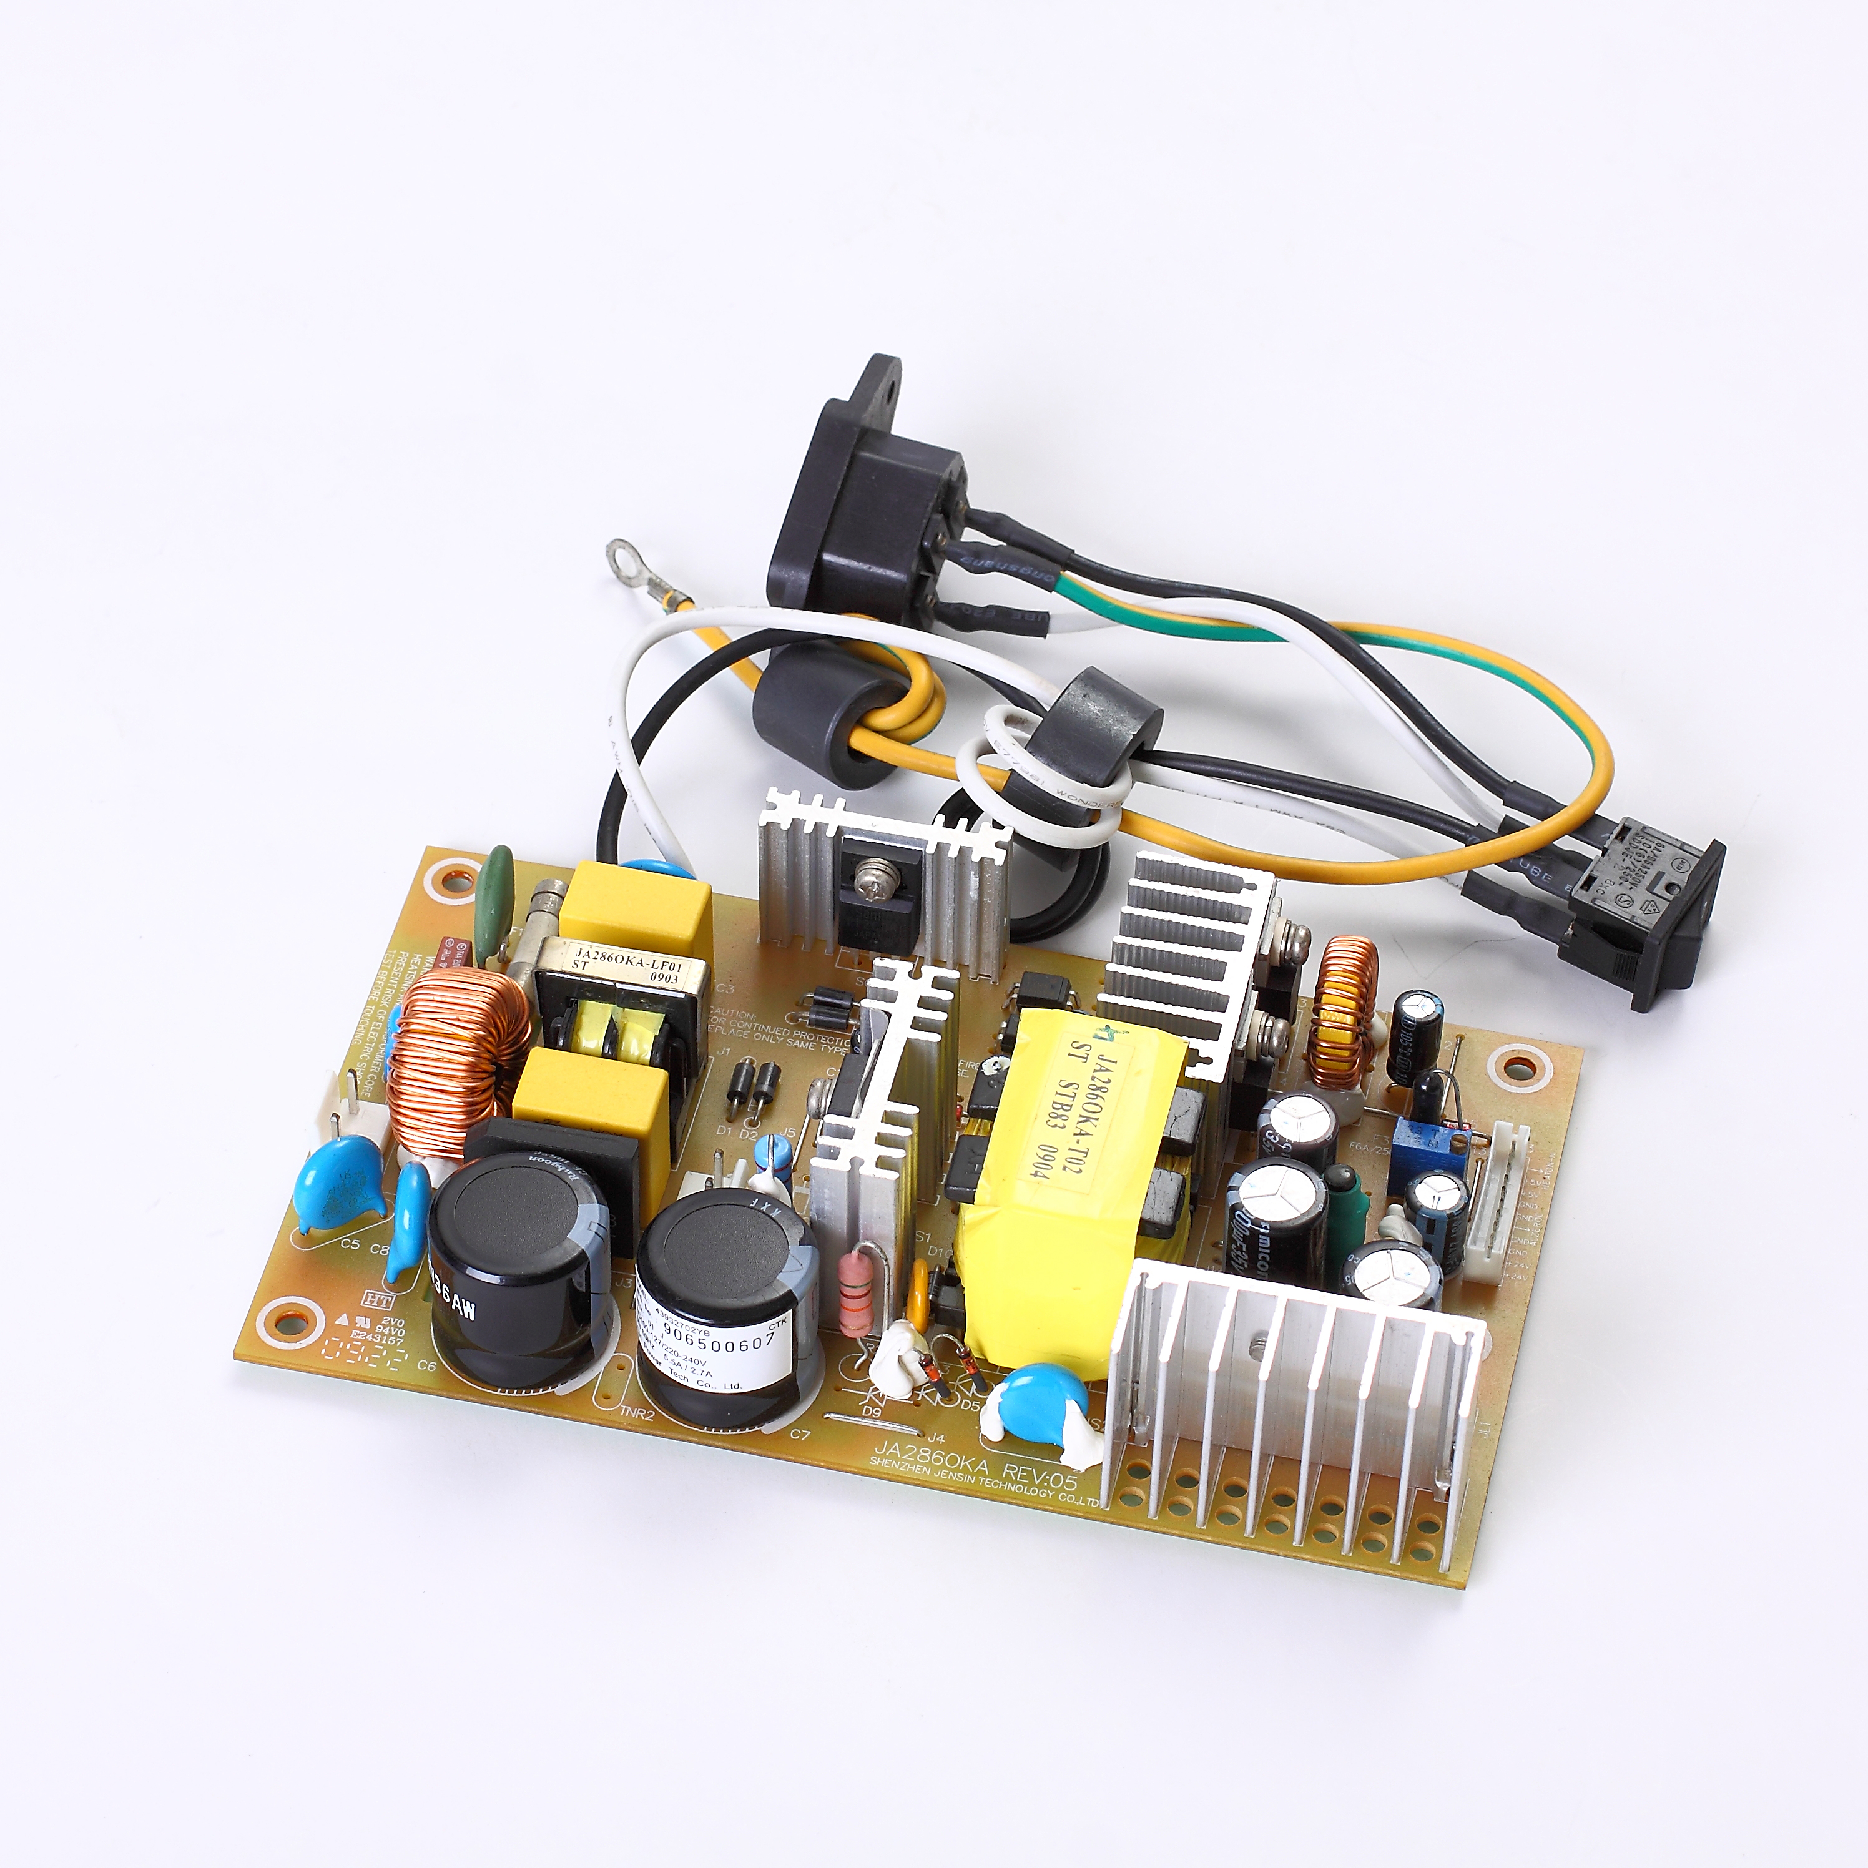

GREEN·POWER
规格

输入
输入电压 | ·90-140 VAC/198-264 VAC
输入频率 | ·47-63 Hz
输入电流 | ·5.5 A max at 100 VAC, full load  ·2.7 A maxat 230 VAC, full load
浪涌电流 | ·45 A max at 230 VAC,  ·30 A max at 100 VAC, cold start at 25 °C
输入保护 | ·Internal T12A250V and T4A250V fuse in  Line and neutral
输出
输出电压 | ·V1:5 VDC,V2:24VDC
输出电流 | ·3.1A V1,2.5A V2
输出 | ·±4%V1,±4%V2
电压修正 | ·±0.5% V1
初始设置精度 | ·0.3A V1; 0A V2
最小负载 | ·4.3A V1; 5.4A V2
最大负载 | ·2S max
启动延迟 | ·0.1S max
启动上升时间 | ·20 ms min at 100 VAC or 220VAC
保持时间 | ·±0.2% after 20 min warm up
温度漂移 | ·±0.5% max
线路调节 | ·±2% V1, ±2% V2
负载调节 | ·4% max. deviation, recovery to within  1% in 500 µs for a 50-75-50% load  change
瞬态响应 | ·2% pk-pk, bandwidth full
波纹和噪声 | ·8.5V max V1, 38V max V2  (Recovery)
过压保护 | ·10A max V1(Cut-off)  8A max V2(Recovery)
过载保护 | · V1(Cut-off), V2 (Recovery)
AC DC
常规
效率 | ·Up to 75% at rating load
隔离 | ·3300 VAC 2S Input to Output,  3300 VAC 2S Input to Ground,
控制信号 | ·HEATON-N and ACZEROCROSS
MTBF | ·60000H or more
环境
工作温度 | ·0 °C to +50 °C
冷却 | ·Fan cooled
工作湿度 | ·10-85% RH, non-condensing
储存温度 | ·-10 °C to +75 °C Non binding
工作高度 | ·3000 m max
震动 | ·50mm highly vertical drop 2 times  on the ground or plate
振动 | ·Operating 0.3g, No Operating 1g,  Number of vibration :5-150Hz,1 minutes  Times: 30 minutes/direction,3 direction(1.5H)
EMC和安全
排放 | ·EN55022 Class B、VCC I Class B 、FCC \ Class B
交流线路抗噪声 | ·JEITA IT-3001、EN55024(EN61000-4-4)
辐射噪声 | ·EN55022 Class B、VCC I Class B 、FCC Class B
静电噪声 | ·JEITA IT-3001、EN55024(EN61000-4-2)
浪涌 | ·EN55024（EN61000-4-5）
传导噪声 | ·EN55022 Class B、VCC I Class B 、FCC Class B
安全认证  （100-127V） | ·UL60950-1, CSA C22.2 No.60950-1,  IEC60950-1, J60950, CNS14336.
安全认证  （220-240V） | ·EN60950-1, IEC60950-1,  PSB, C-TICK, s-mark, CCC,K-MARK

SHENZHEN CEC PANDA JENSIN TECHNOLOGY CO., LTD

