彩色打印机电源

www.jensin.cn

JA750OKA
· 165 W 对流冷却
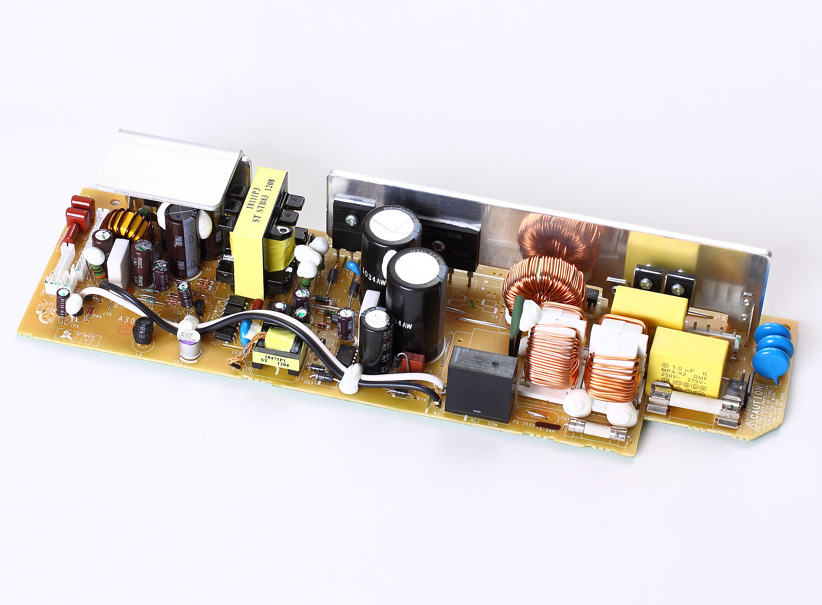

· 338 W 峰值
·省电模式
· 3.3V待机功能
·尺寸: L(285mm) x W(80mm) x H(47mm)
· IT 安全认证
· 5 年保修期

GREEN·POWER
规范

输入
常规

输入电压
输入频率
输入电流
浪涌电流
· 90-127VAC
· 47-63 Hz
· 5.0 A typical at 90 VAC, full load
· 30 A max at 140 VAC, cold start at 25 °C
节电模式
· DC output in 0.7W (3.3V/0.21A) power
Consumption 1.0W or less
DC output in 2W (3.3V/0.6A) power
Consumption 2.85W or less

输入保护 · Internal T6.3 A/250 V fuse in line
and neutral

输出
输出电压 · V1:3.3V;V2:5.0V;V3:24V
输出电流 · V1:1.5A;V2:6.3A;V3:6.8A
输出电压修正 · ±5%
启动延迟 · 1.5 s typical
启动上升时间 · 0.2 s MAX
保持时间 · 20 ms min at 100VAC

输出
隔离 · 3300 VAC Input to Ground,
信号 · Power save Inhibit, 3.3 V Standby
MTBF · 50000H or more in Ambient temperature 50°C
环境
工作环境 · 0 °C to +50 °C
冷却 · Forced air cooling by FAN
工作湿度 ·10% to 85% RH, non-condensing
储存温度 · -10 °C to +60 °C
工作高度 · 3000 m
震动 · Conditions for dropping impact:Drop hor izontally on
the concrete floor Height:50mm
EMC和安全

漂移
·
±0.2% after 20 min warm up

线路调节
负载调节
瞬态响应

波形和噪音

过压保护

过载保护

电路保护
·
·
·
·

±0.5% max
±2% V1, ±2% V2, ±2% V3
4% max. deviation, recovery to within
1% in 500 µs for a 50-75-50% load
change
V1andV2:250mVp-p, V3:500mVp-p20 MHz bandwidth
V1:4.5Vmax, V2:7.0Vmax, V3:32Vmax,
Latch off mode

·V1:3Amax, V2:15Amax, V3:13Amax
Latch off mode

·Latch off mode

爆发性噪音

高频连续传导

工频磁场

传导噪音

辐射噪音

谐波电流
·comply with JEITA IT-3001 and EN55024
Power supply line:±1.5KV

comply with JEITA IT-3001 and EN55024
Power supply line: 5V

comply with JEITA IT-3001 and EN55024
Power frequency magnetic field :3A/m

· FCC Class B,VCCI Class B,EN55022 Class B

· FCC Class B,VCCI Class B,and EN55022 Class B
·
.EN61000-3-2, JIS C 61000-3-2

·

AC DC

SHENZHEN CEC PANDA JENSIN TECHNOLOGY CO., LTD

