ATM-计算机辅助电源系统

www.jensin.cn

JA1432OKA
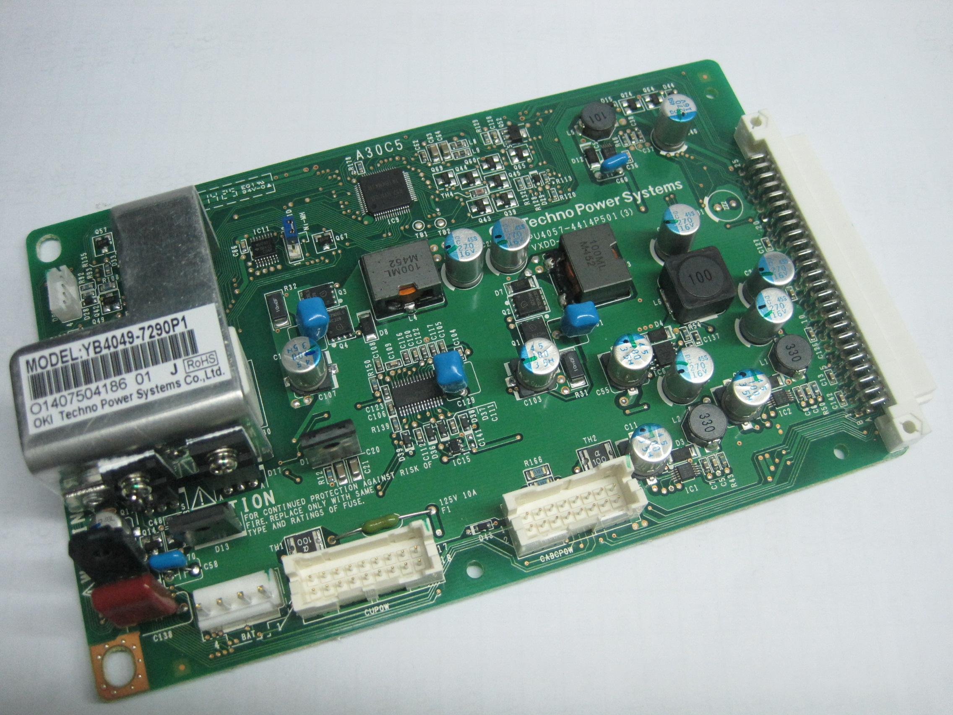

GREEN·POWER
·137.85W 额定功率
·145W 直流输出功率（24V）
·功效高达 95%
·尺寸: L(167.0) X W(105) X H(35) (mm)
·工业安全审批
·5年保质期
规范

输入
输入电压 | ·23-25VDC
输入频率 | ·NOR
输入电流 | · A max at VAC, full load
浪涌电流 | ·10 A max at 24 VDC, cold start at 20 °C
输入保护 | ·24VDC：Internal T10A/125V fuse in Line and neutral
输出
输出电压 | ·V1: 3.3VDC, V2:5VDC, V3:12VDC,  V4:5VSDC, V5:12VADC, V6:-12VDC  V7:25VCABDC
输出 | ·3.135～3.465V V1, 4.8～5.3V V2  11.712～12.566V V3,4.75～5.25V V4  11.4～12.6V V5, -10.8～-13.2V V6  20.4～27.6V V7  (see Mechanical Details)
电压修正 | ·NOR
初始设置精度 | ·2.5A V1; 4.0A V2; 6.5A V3; 1.0A V4  1.5A V5; 0.3A V6; 0.2A V7
额定负载 | ·1.6 s max
启动延迟 | ·0.1 s maxl
启动上升时间 | ·20 ms min at 24 VDC
保持时间 | ·±0.5% after 20 min warm up
温度漂移 | ·±0.5% max
线路调节 | ·0～3A V1, 0～6A V2, 0～7A V3  0～1A V4, 0～1.5A V5, 0～0.3A V6  0～0.2A V7
负载调节 | ·V1、2、4 Below of 150mV pk-pk,  V3、5、6 Below of 220mV pk-pk,  V7 NO provisions  Bandwidth 20MHz
波纹和噪声 | ·Output overvoltage, fuse(F1、F4) on PCB  will be broken, not to implement
过压保护 | ·3.1～6.0A V1, 6.3～9.0A V2,  7.35～11.5A V3 , 2.0～3.0A V4,  1.8～2.7A V5, 0.36～2.5A V6,  V7 not to implement
过载保护 | ·2.97V↓V1, 4.54V↓V2, 11.1V↓V3,  4.54V↓V4, 10.8V↓V5, -10.8V↓V6,  V7 NOR

常规
效率 | ·Up to 95% at rating load
隔离 | ·NOR
控制信号 | ·P-ON/OFF,EPO-SW
MTBF | ·100000H or more
环境
工作温度 | ·5°C to +35 °C
冷却 | ·Forced air cooling
工作湿度 | ·65%±20% RH, non-condensing
储存温度 | ·-10 °C to +65 °C Non binding
工作高度 | ·3000 m max
震动 | ·Operating 5g, No Operating 30g,  X, Y, Z in each direction, each of the 3 back
振动 | ·3mm, 5HZ to 20KHz, 3axes
EMC和安全
排放 | ·EN55022 Class B、VCC I Class B 、FCC Class B  EN55024 Class B、IEC6100-3、EN6100-3
浪涌 | ·IEC1000-4-5
安全认证 | ·J60950(H19),UL60950-1, JISC6950:2006,  CAN/CSA,C22.2No.60950-1-07

