电力系统控制电源
AC DC
MODEL NO: JA419NZA
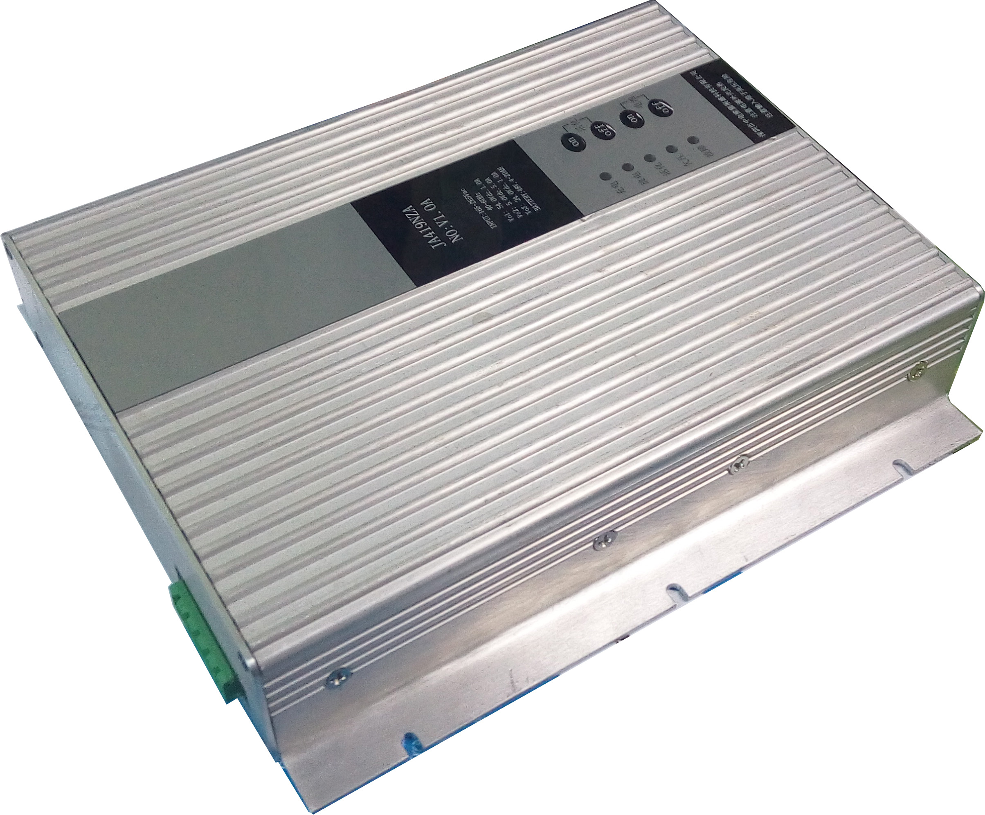
· 176VAC至264VAC通用输入范围
· 146 W额定输出功率
· 功效高达78％
· 尺寸: 194L×168W×42H (mm)
· 符合UL，CQC，CE认证
· 符合RoHS标准
www.jensin.cn

规格
输入 |  |  | 常规
输入电压 | 176-264 VAC |  | 功效 | Up to 78%
输入频率 | 47-63 Hz |  | 隔离 | 3000 VAC Input to Output
输入电流 | 2.5A typical at 230 VAC, full load |  | MTBF | 100000 Hours
浪涌电流 | 40A max at 230 VAC, cold start at 25 °C |  | 绝缘电阻 | more than 50MΩ at 500Vdc between Primary Live,Neutral line and second- dary
输入保护 | Internal T6.3 AH/250 V fuse in line and neutral |  | 绝缘电阻
待机功耗 | NOR |  | 漏电流 | 0.25mA maximum, at nominal AC in- put voltage and frequency
输出 |  |  | 漏电流 | 0.25mA maximum, at nominal AC in- put voltage and frequency
输出电压 | V1,54V V2,5.0V V3,24V |  | 重量 | 1250g
输出电压范围 | V1,53.5V~54.5V V2,4.8V~5.2V  V3,22.8V~25.2V
输出电压范围 | V1,53.5V~54.5V V2,4.8V~5.2V  V3,22.8V~25.2V |  | 环境
输出电压范围 | V1,53.5V~54.5V V2,4.8V~5.2V  V3,22.8V~25.2V |  | 冷却 | Convection cooled
输出电流 | V1, 1A V2, 5A V3, 1A |  | 工作湿度 | 95% RH, non-condensing
输出电流 | V1, 1A V2, 5A V3, 1A |  | 储存温度 | -20 °C to +70 °C
输出电压修正 | ±3% |  | 工作高度 | 3000 m
初始设置精度 | ±5% |  | 震动 | 30 g pk, half sine, 6 axes
最小负载 | 0A |  | 振动 | 2 g rms, 5 Hz to 500 kHz, 3 axes
启动延迟 | 1.8 s typical
启动上升时间 | 0.2 s typical |  | EMC 和安全
保持时间 | 20 ms min at 230 VAC |  | 传导发射 | EN55022, level B
温度漂移 | ±0.3% after 20 min warm up |  | 辐射发射 | EN55022, level B
波形和噪音 | Vo1, Below of 400mV pk-pk,  Vo2, Below of 50mV pk-pk,  Vo3, Below of 200mV pk-pk,  Provisions Bandwidth 20MHz |  | ESD 空气 | EN61000-4-2, level 3 Perf. criteria 1
过压保护 | Vo1, 60V (59~61)  Vo2, 5.7V (5.5~5.9)  Vo3, 27.5V (26.5~28.5) |  | ESD 接触 | EN61000-4-2, level 4 Perf. criteria 1
过压保护 |  |  | 浪涌 | EN61000-4-5, level 3 Perf. criteria 1
过载保护 | Vo1, 7.0～9.0A  Vo2, 10～15A  Vo3 , 5.0～7.0A |  | 快速瞬变 | EN61000-4-4, level 3 Perf. criteria 1
输入欠压保护 | DC48V, 42V (41~42.5) |  | 辐射免疫 | EN61000-4-3, level 3 Perf. criteria 2
 |  |  | 传导免疫 | EN61000-4-6, level 3 Perf. criteria 1

SHENZHEN CEC PANDA JENSIN TECHNOLOGY CO., LTD

