LCD PANEL BACKLIGHT POWER www.jensin.cn


JC24645CEC
GREEN·POWER
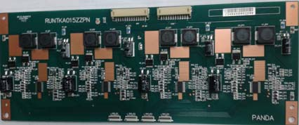
·64.5’’ LED Driver ·155.5W DC Out Power · Efficiency up to 95% · Adjustable Brightness · Size: L(262) X W(100) X H(12) (mm) · RoHS & Halogen Free · 5 Year Warranty
Specification
Input
input Voltage Input Frequency Input Current
Inrush Current Input Protection
Output
Output Voltage
Output Voltage Trim
Initial Set Accuracy Rated Load
Open Lamp Protection
 | General
·23-26VDC · | Efficiency Isolation | ·Up to 95% at rating load ·NOR
·7.2A max at 24Vdc, full load | Control Signals | ·VBLON
 | MTBF | ·100000H or more
· ·24VDC：Internal fuse Protection | Environmental
·V: 54VDC | Operating Temperature Cooling Operating Humidity Storage Temperature | ·0°C to +50 °C ·Forced air cooling ·20%~85% RH, non-condensing ·-20 °C ~ +70 °C Non binding
 | Operating Altitude | ·3000 m max
·V: 57VDCmax | Shock Vibration | ·Operating 5g, No Operating 30g, X, Y, Z in each direction, each of the 3 back ·3mm, 5HZ to 20KHz, 3axes
·NOR ·120±3mA * 24Channel | EMC & Safety Emi | ·EN55013 Class B、GB13837 Class B 、FCC
 |  | Class B
 |  | EN55024 Class B、IEC6100-3、EN6100-3
 | Ems | ·GB17626-1998、 IEC61000
·Shutdown & ERR Signal:an active-high | Safety Approvals | ·UL60065、 E N60065 、GB8 898-2001
TTL-compatible


SHENZHEN CEC PANDA JENSIN TECHNOLOGY CO., LTD

